//CS4370

//Parallel Programming for Many-Core GPUs

//Avery Colley

//Meilin Liu

//12/12/24

//Programming Assignment #1 - Basic Matrix Addition

//Compiling command: nvcc Colley_Project1Task1.cu -o matrixAdd

//Compiling command: nvcc Colley_Project1Task2.cu -o matrixMult

Report:

The program for both tasks has all of the functionalities described in the project description.

Matrix addition with a matrix of size 128x128: 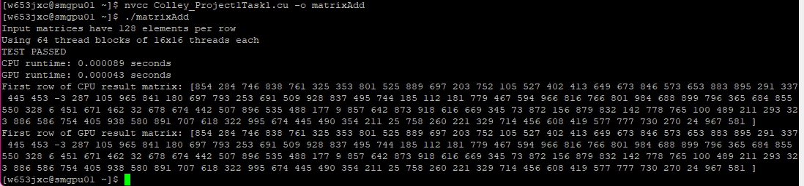

Matrix addition with a matrix of size 500x500:

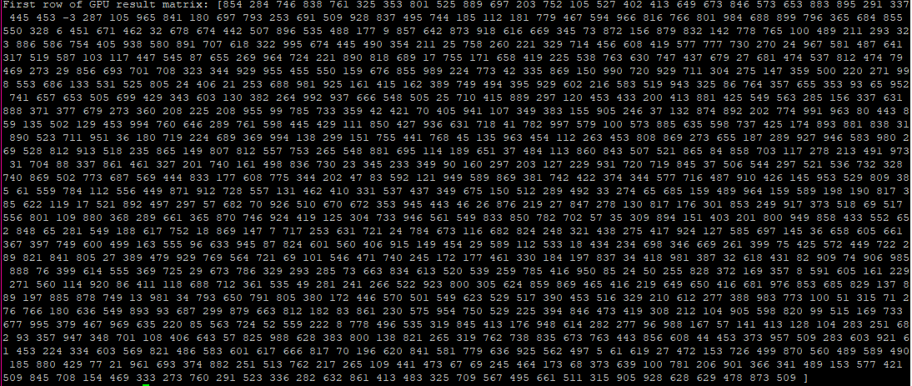

Matrix multiplication with a matrix of size 128x128:

Matrix multiplication with a matrix of size 500x500:

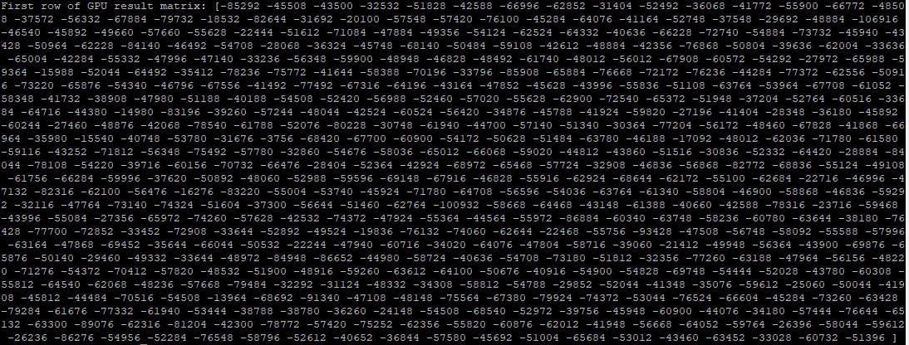

Matrix multiplication with a matrix of size 1024x1024:

